SAMS

Semi-Automated MEA Spike Sorting

User Manual

Version 1.0

Zhao Lab | Hai Lab | Rosenberg Lab

University of Wisconsin-Madison

<https://github.com/Zhao-Lab-UW/SAMS>

# Citation

If you use SAMS in your research, please cite:

Ren X, Sirois CL, Doudlah R, Bhattacharyya A, Bhattacharyya A, Mendez-Albelo NM, Bhattacharyya A, Hai A, Rosenberg A, Zhao X. (2025). A Semi-Automated MEA Spike sorting (SAMS) method for high throughput assessment of cultured neurons. *bioRxiv*. DOI: [10.1101/2025.02.08.637245](https://doi.org/10.1101/2025.02.08.637245)

**RRID:** [pending]

# Overview

SAMS is a MATLAB-based application for spike sorting multi-electrode array (MEA) recordings. It was developed to address the need for efficient, reproducible spike sorting in high-throughput neuronal culture experiments—particularly for iPSC-derived neurons where traditional sorting methods can be time-consuming.

The pipeline has two components:

* **SAMS (automated sorting)** – batch processes .spk files, performs spike detection and clustering, and runs burst analysis
* **SAMS_ManualSpikeSorting** – allows manual review and correction of sorting results, useful for electrodes where automated clustering struggles

Most electrodes won't require manual curation, but the option is there for cases with overlapping clusters or ambiguous waveforms.

# Installation

## Requirements

* Windows 10 or later
* 16 GB RAM (recommended)
* ~8 GB disk space for MATLAB Runtime
* **MATLAB Runtime R2023b** – free download from MathWorks (version 9.15, Windows 64-bit)

## Setup

1. Install MATLAB Runtime R2023b first. This takes 10-15 minutes.
2. Download and extract the SAMS folder from the GitHub repository.
3. Double-click to run. If you get a permissions error, try running as administrator.

# Automated Sorting

## Interface Overview

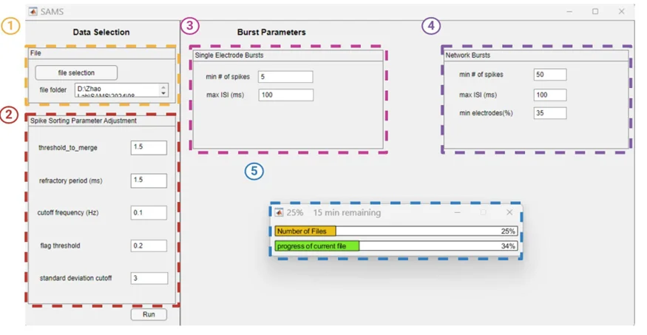

**Figure 1. SAMS automated sorting interface.** (1) Data Selection panel for loading .spk files. (2) Spike Sorting Parameter Adjustment panel with configurable thresholds. (3) Single Electrode Bursts parameters. (4) Network Bursts parameters. (5) Progress dialog showing processing status and time estimate.

## Running the Pipeline

1. **Select your data folder.** Click "file selection" and navigate to the folder containing your .spk files. SAMS will process all .spk files in the folder sequentially.(Fig2, left)
2. **Check parameters.** The defaults work well for most recordings, but adjust if needed (see Parameter Reference below).
3. **Click Run.** The progress dialog will show overall progress and current file status with time estimates.

## Input/Output Files

SAMS creates a Results folder containing output for each recording(Fig2, right):

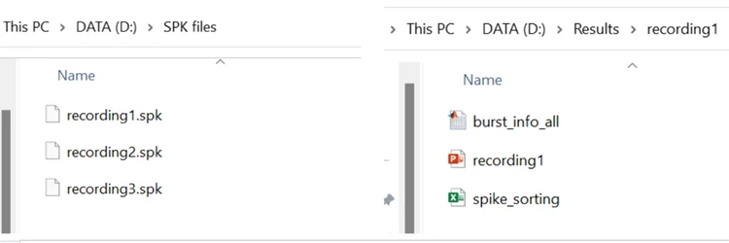

**Figure 2. Input and output file organization.** Left: Input folder containing .spk files for batch processing. Right: Output files generated for each recording, including burst_info_all.mat, spike_sorting.xlsx, and a PowerPoint summary.

## Output Spreadsheet (spike_sorting.xlsx)

The main output file contains five sheets with comprehensive sorting results and metadata:

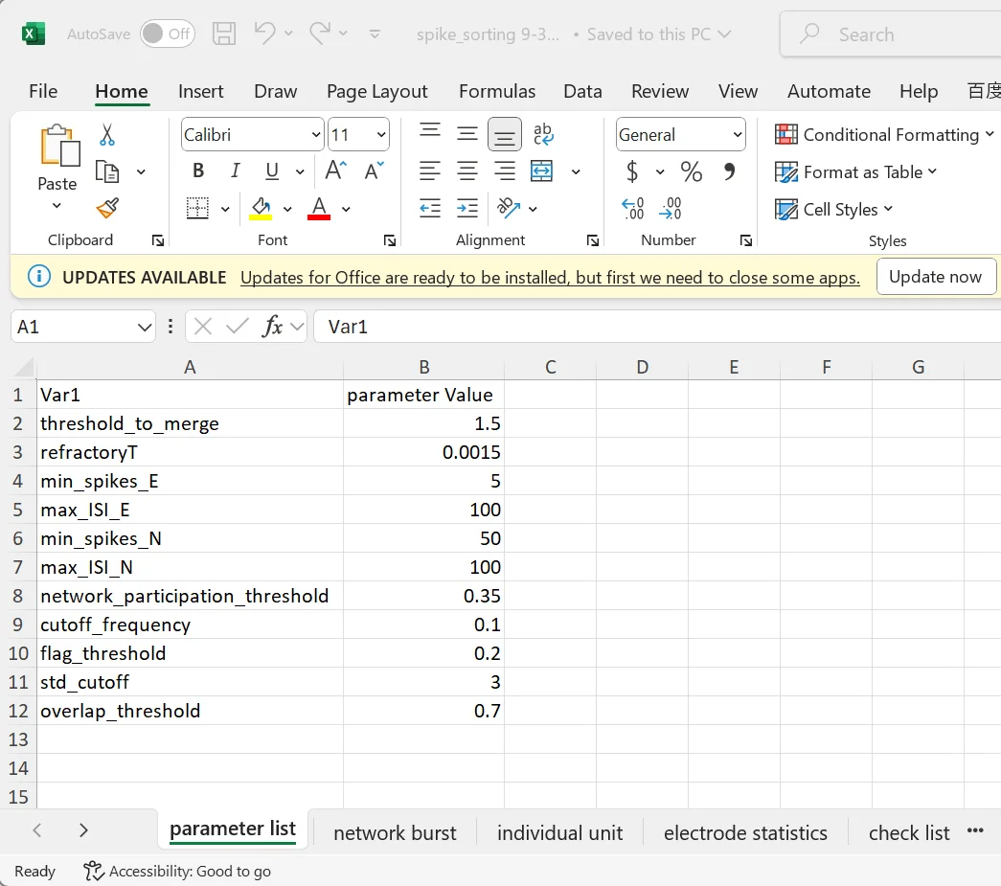

**Figure 3. Parameter list sheet.** Records all spike sorting and burst detection parameters used for the analysis.

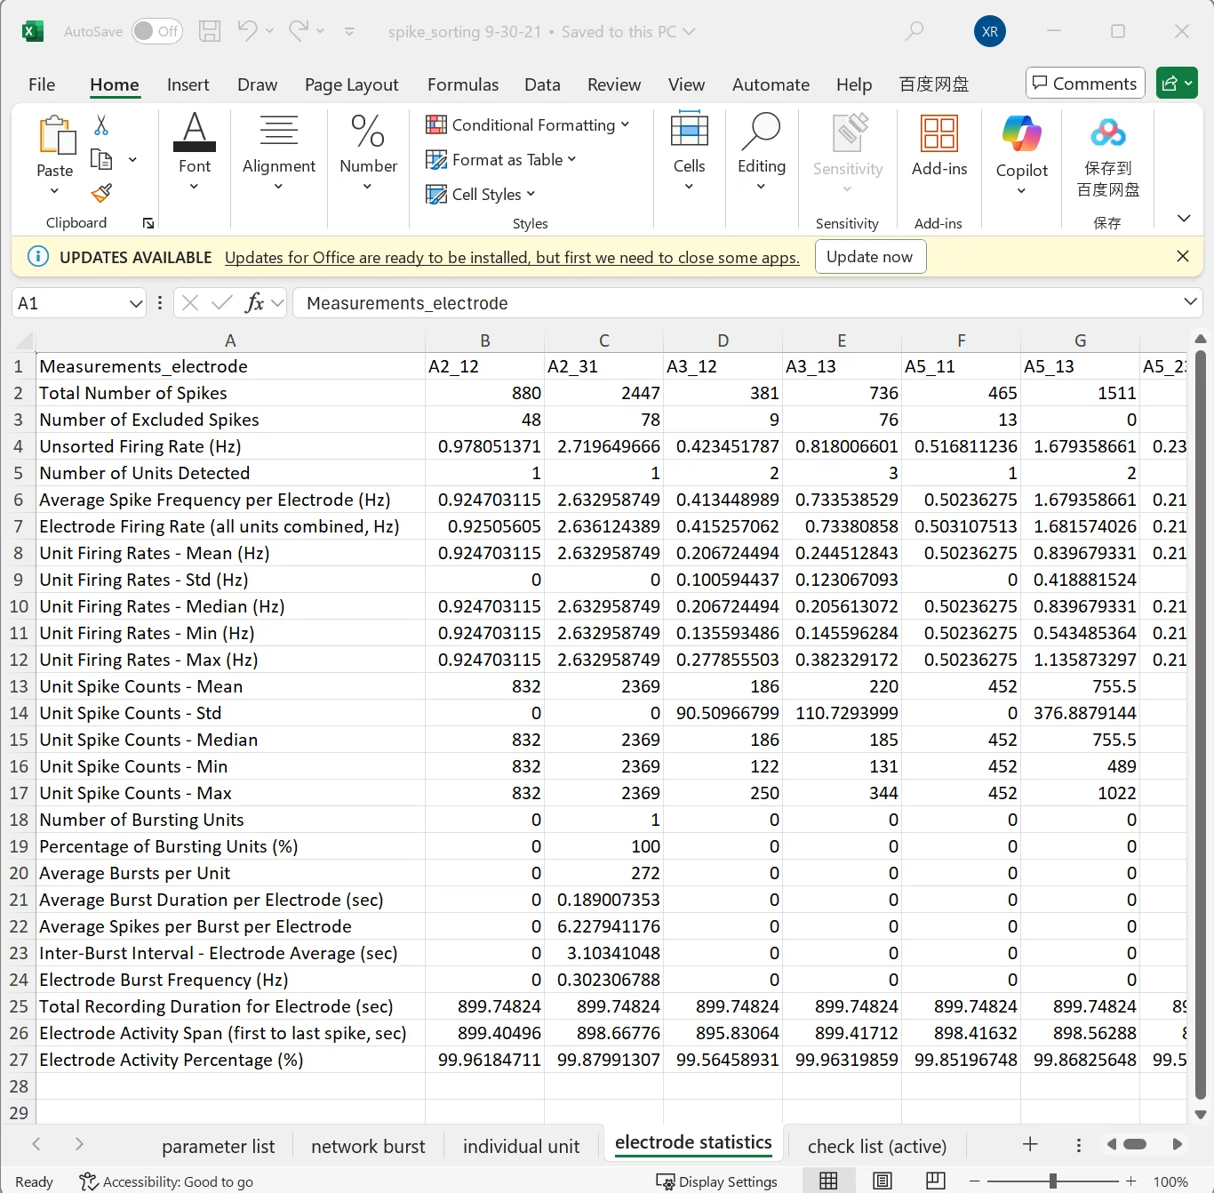

**Figure 4. Electrode statistics sheet.** Summary metrics for each electrode including total spike count, number of units detected, firing rates, burst statistics, and activity duration.

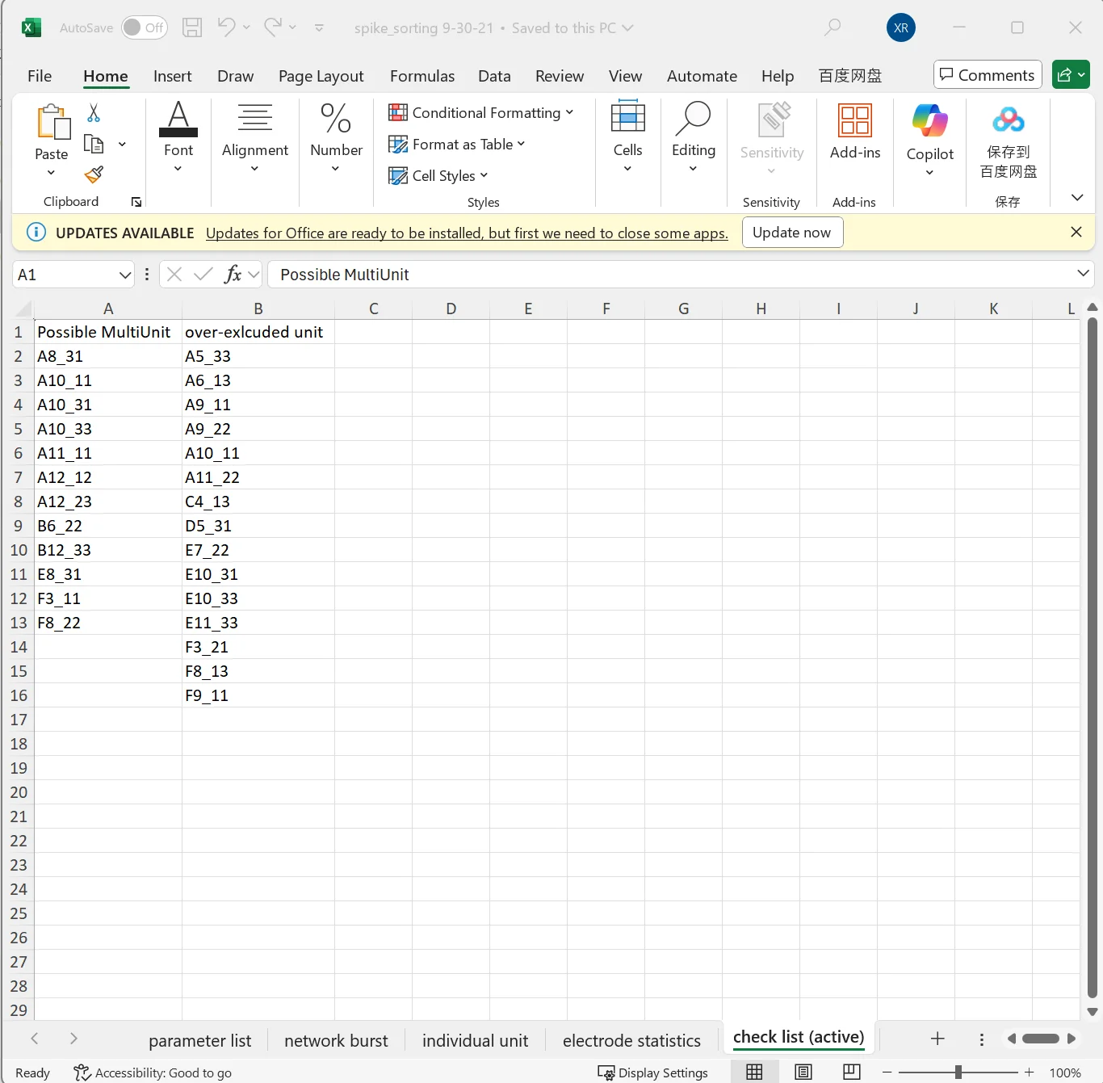

**Figure 5. Check list sheet.** Flags electrodes that may require manual review. "Possible MultiUnit" lists electrodes with potentially under-split clusters; "over-excluded unit" lists electrodes where many spikes were excluded during sorting(>20% Waveforms).

## Visual Summary (PowerPoint)

SAMS generates a PowerPoint file with one slide per electrode, useful for quick visual inspection of sorting quality:

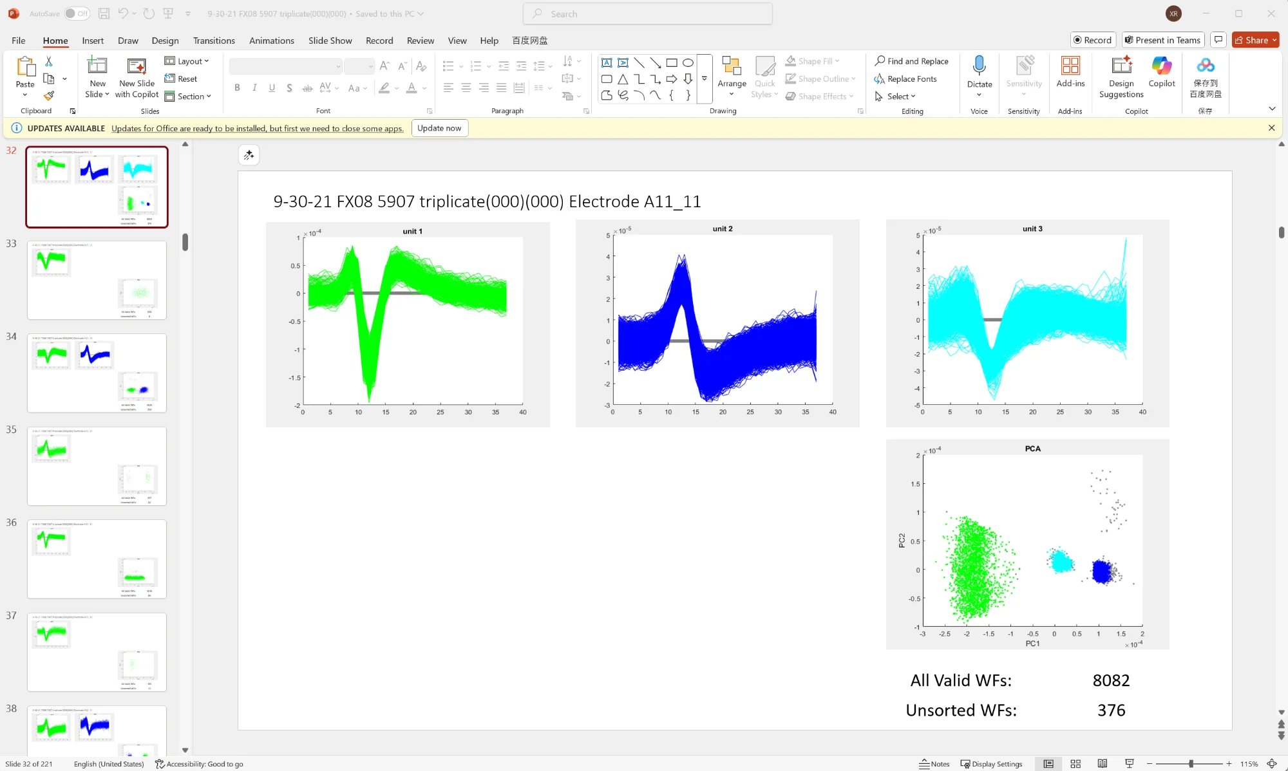

**Figure 6. PowerPoint output.** Each slide shows waveforms for detected units (color-coded), PCA clustering, and spike counts. Scroll through slides to review sorting quality across electrodes.

# Manual Sorting

The manual sorting GUI lets you review automated results and make corrections. You'll need the output files from the automated pipeline (spike_sorting.xlsx, .spk files, and burst_info_all.mat). Focus on electrodes flagged in the check list sheet.

## Interface Layout

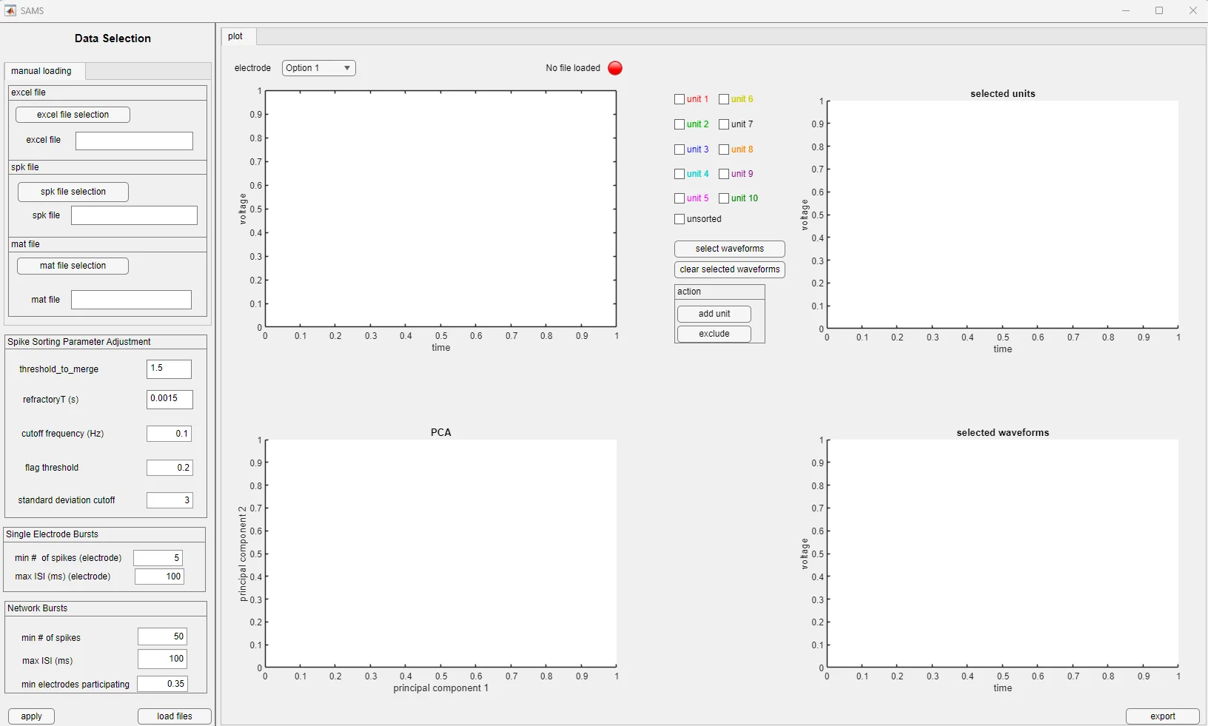

**Figure 7. Manual sorting interface.** Left panel: file selection and parameters. Center top: waveform display with spikes color-coded by unit. Center bottom: PCA plot showing cluster separation. Right panel: unit selection checkboxes, action buttons, and selected waveforms display.

**Left panel:** File selection and parameters. Load your three files here, then click "load files." Parameters are pre-filled with default values and should match the "parameter list" sheet in your spike_sorting.xlsx output file."

**Center top:** Waveform display showing all spikes from the current electrode, color-coded by unit.

**Center bottom:** PCA plot. Useful for seeing how well clusters separate.

**Right panel:** Unit selection checkboxes and action buttons. The "selected units" plot shows waveforms from checked units.

### Status Indicator

The colored circle next to the electrode dropdown shows loading status:

**Figure 8. File loading status indicators.** Red: no file loaded. Yellow: loading in progress. Green: file loaded successfully.

# Manual Sorting Workflow

## Loading Data

1. Use the file selection buttons to load spike_sorting.xlsx, your .spk file, and burst_info_all.mat.
2. Click "load files" and wait for the green indicator.
3. Select an electrode from the dropdown menu.

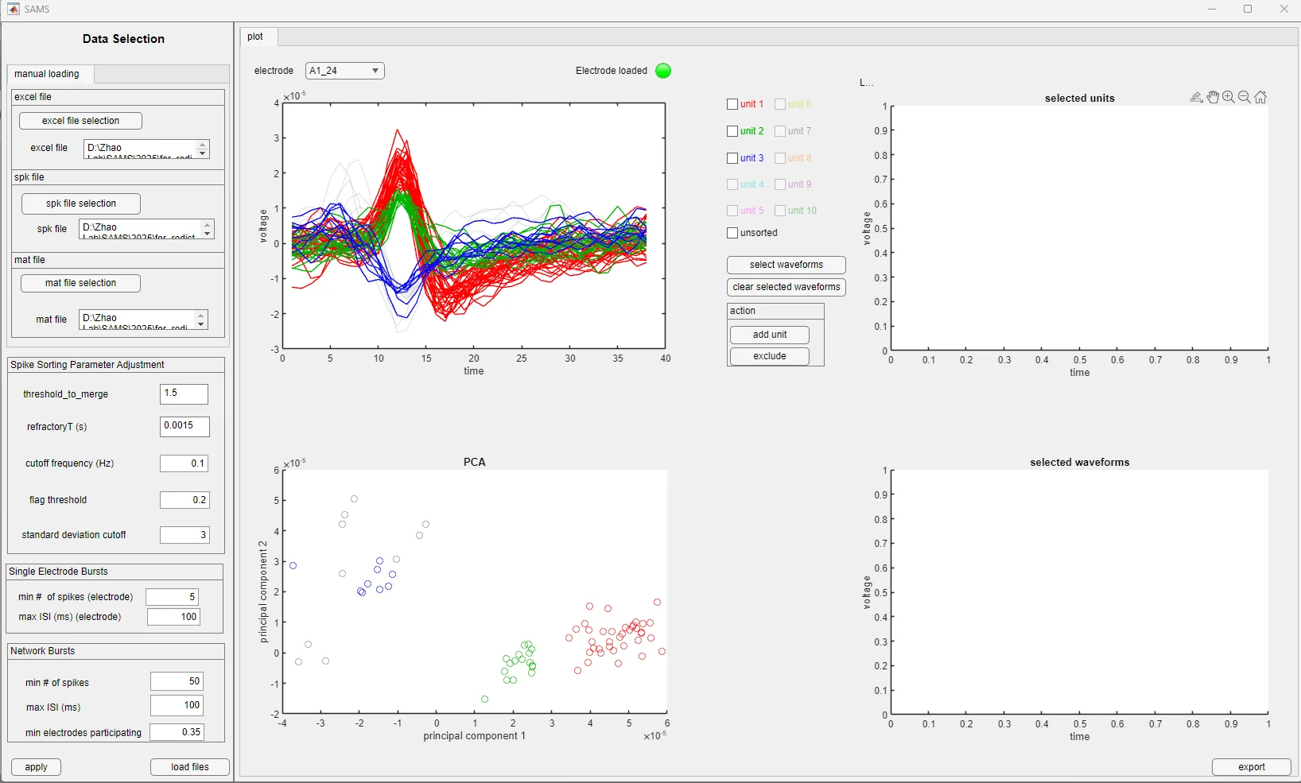

**Figure 9. Interface after loading electrode data.** Electrode A1_24 showing three automatically detected units (red, green, blue) in the waveform plot and corresponding clusters in the PCA plot.

## Reviewing Units

Check the boxes for units you want to inspect. The waveforms will appear in the "selected units" panel on the right. The PCA plot shows how clusters separate in principal component space—well-isolated units should form distinct groups.

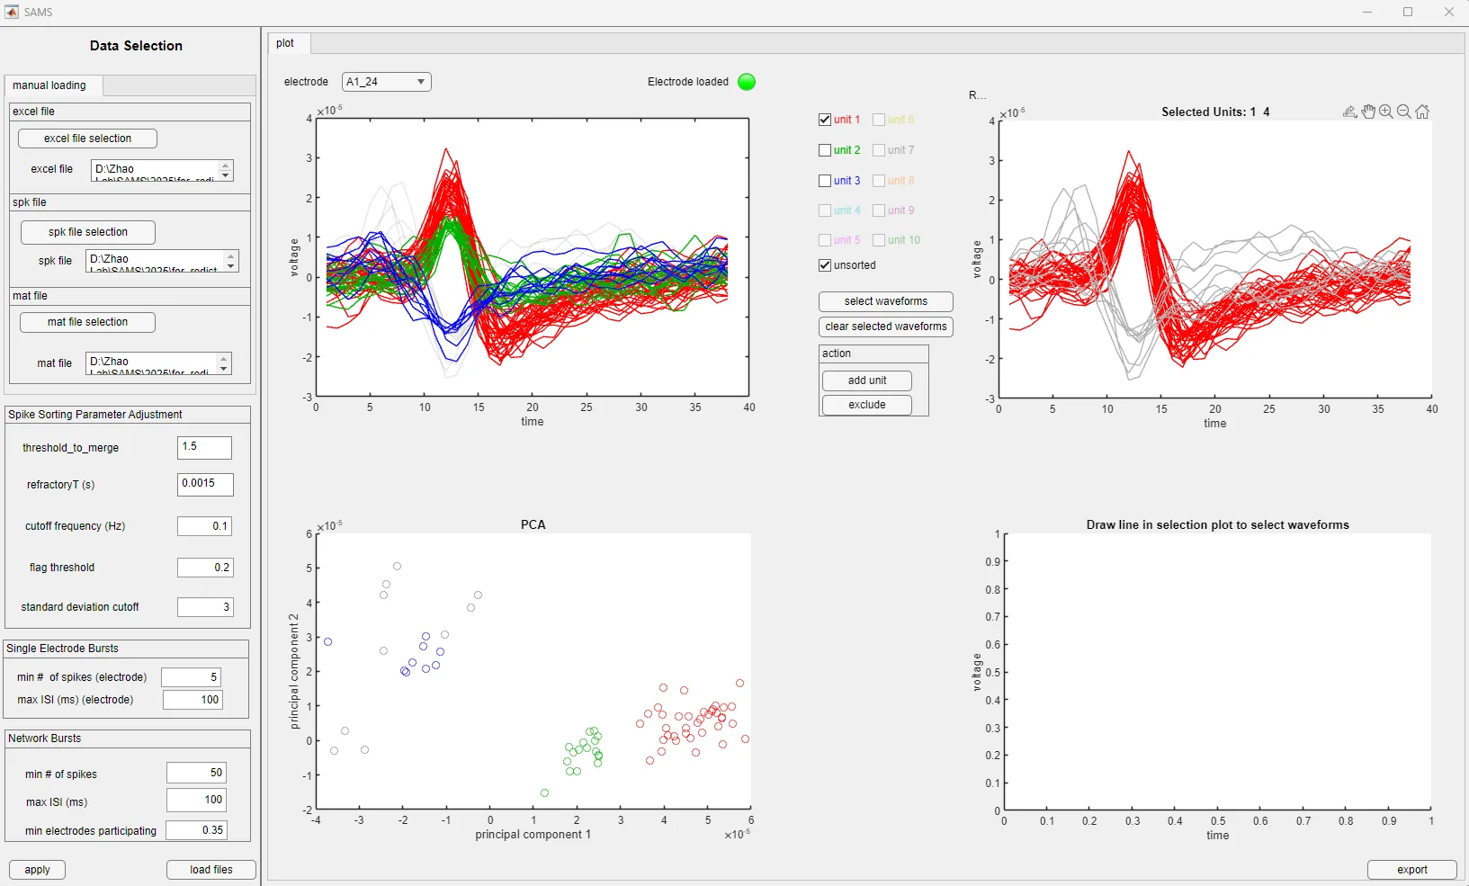

**Figure 10. Viewing selected units.** As an example, unit 1, and unsorted waveforms displayed in the selected units panel. Users can check multiple unit boxes to compare waveforms across clusters.

## Selecting Waveforms

To select specific waveforms for reassignment or exclusion, click "select waveforms" then draw a line across the waveforms you want in the selection plot. The selected waveforms appear in the bottom-right panel.

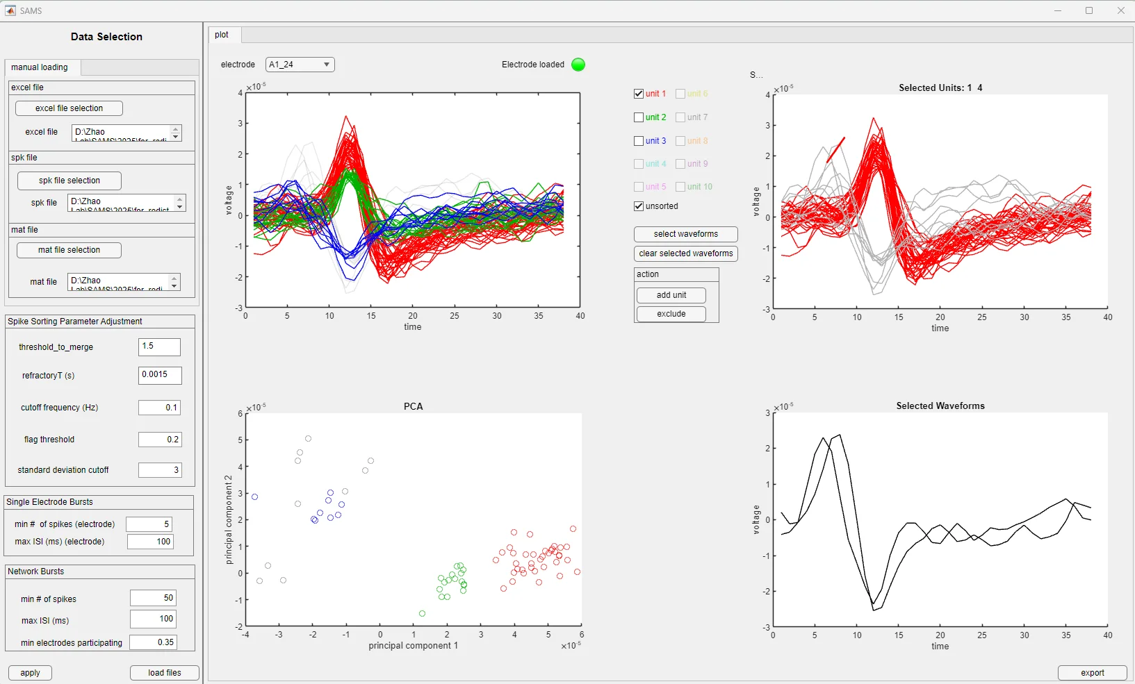

**Figure 11. Selecting waveforms for action.** After clicking "select waveforms," draw a line across the selection plot to capture specific waveforms. Selected waveforms appear in the bottom right panel.

## Reassigning Waveforms

After selecting waveforms, click "add unit" to reassign them. A dialog lets you choose the destination—either an existing unit or create a new one.

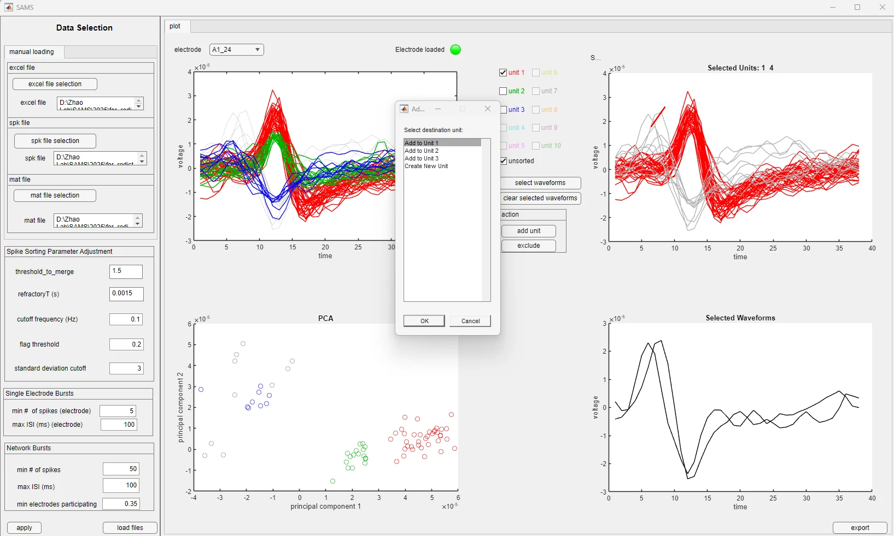

**Figure 12. Unit assignment dialog.** Users can assign selected waveforms to an existing unit (Unit 1, 2, or 3) or create a new unit.

## Excluding Waveforms

Sometimes a unit contains obvious artifacts or misclassified spikes. Select the problem waveforms and click "exclude" to remove them from the unit.

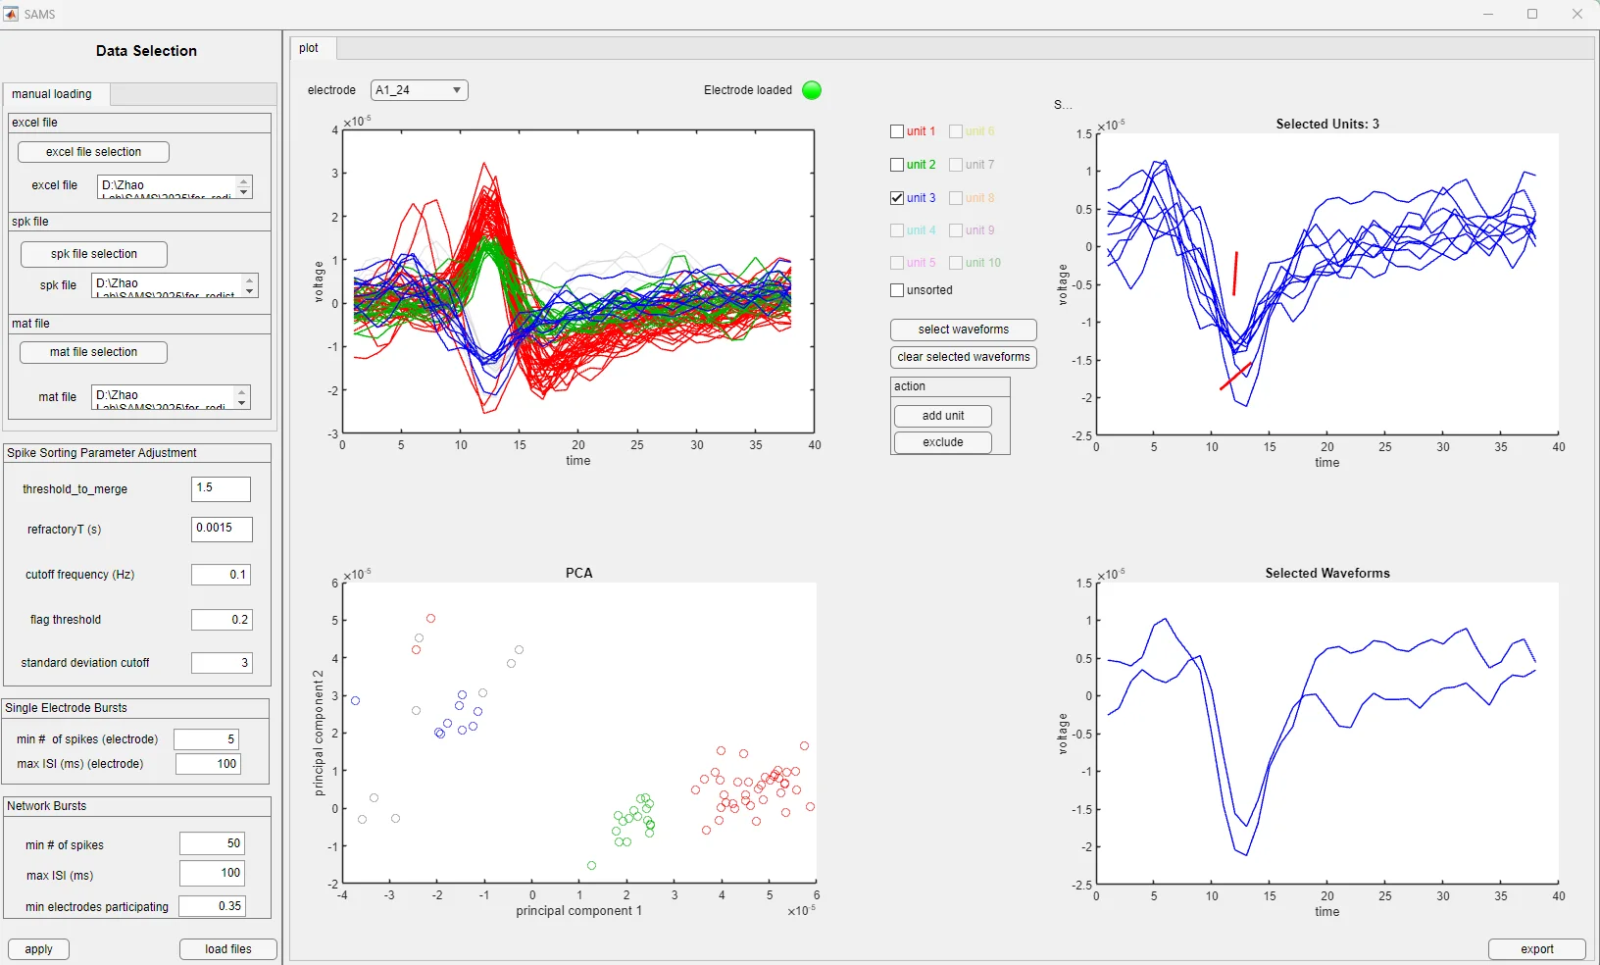

**Figure 13. Selecting waveforms for exclusion.** Waveforms from Unit 3 selected for removal. The highlighted waveforms will be excluded after clicking the "exclude" button.

## Exporting

When you're done with corrections, click "export" and choose an output folder. Results go into an "adjusted sorting results" subfolder.

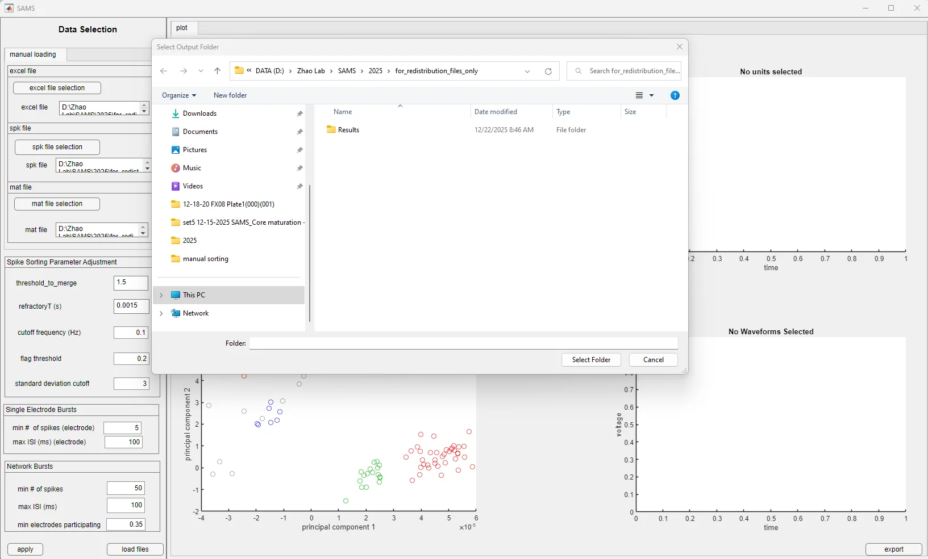

**Figure 14. Export folder selection.** Dialog for choosing the output location. Adjusted sorting results are saved in a subfolder within the selected directory.

# Parameter Reference

These defaults have worked well across our iPSC-derived neuron datasets, but you may need to adjust them for different preparations.

| **Parameter** | **Default** | **Description** |
| --- | --- | --- |
| threshold_to_merge | 1.5 | DTW distance threshold for merging templates |
| refractoryT (s) | 0.0015 | Refractory period for detecting violations |
| cutoff frequency (Hz) | 0.1 | Cutoff frequency for active units |
| flag threshold | 0.2 | Threshold for flagging excessive outlier removal (default: 0.2) |
| std deviation cutoff | 3 | For outlier removal |
| min spikes (electrode) | 5 | Minimum spikes to count as individual unit burst on that electrode |
| max ISI (electrode) | 100 ms | Maximum inter-spike interval for individual unit bursts on that electrode |
| min spikes (network) | 50 | Minimum spikes for network burst |
| max ISI (network) | 100 ms | Maximum ISI for network bursts |
| min electrodes | 35% | Electrode participation threshold for network bursts |

# Practical Tips

Start by reviewing the check list sheet in spike_sorting.xlsx. Electrodes flagged as "Possible MultiUnit" or "over-excluded" are good candidates for manual review.

The PowerPoint output is helpful for quickly scanning through electrodes. Look for slides where clusters overlap in the PCA plot or where waveform shapes within a unit look inconsistent.

If you're unsure whether a waveform belongs to a unit, it's often better to leave it unsorted than to force an assignment.

Export periodically if you're curating many electrodes. The interface doesn't auto-save.

# Troubleshooting

**App won't start:** Make sure MATLAB Runtime R2023b is installed (not a different version). Try running as administrator.

**Files won't load:** Check that all three files (xlsx, spk, mat) are from the same recording session.

**No waveforms showing:** Make sure you've selected an electrode and checked at least one unit box.

**Can't select waveforms:** Click "select waveforms" first to enter selection mode.

**Export fails:** Check write permissions on the destination folder.

# Contact

For questions about the SAMS algorithm and implementation:

Xiaoxuan Ren: xren37@wisc.edu

Xinyu Zhao: xinyu.zhao@wisc.edu

**Correspondence:**

**Xinyu Zhao** – Waisman Center and Department of Neuroscience, University of Wisconsin-Madison School of Medicine and Public Health, Madison, WI 53705; xinyu.zhao@wisc.edu

**Aviad Hai** – Department of Biomedical Engineering, University of Wisconsin-Madison College of Engineering, Madison, WI 53706; ahai@wisc.edu

**Ari Rosenberg** – Department of Neuroscience, University of Wisconsin-Madison School of Medicine and Public Health, Madison, WI 53705; ari.rosenberg@wisc.edu

For the latest version and updates: <https://github.com/Zhao-Lab-UW/SAMS_V2>